PULSE OSTRAVA 2025 - TIME TO RESTART
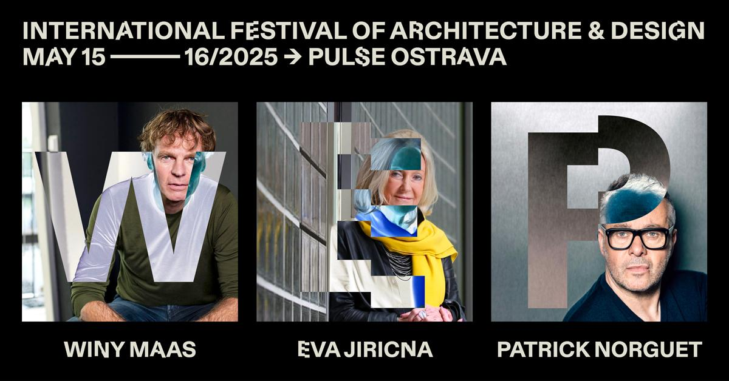
PRODUCT DESIGN | INTERIOR DESIGN | ARCHITECTURE | URBANISM
AUSTRIA | CZECHIA | HUNGARY | POLAND | SLOVAKIA
THEME : RESTART – ARCHITECTURE AND DESIGN IN A CHANGING WORLD
The world is changing - and with it, the role of architecture and design. Under the theme RESTART, the PULSE Ostrava 2025 conference and festival, the largest architecture and design event in Central Europe, will explore how creative disciplines can respond to urgent global shifts. It will stimulate cross-sectoral and cross-border dialogue, connecting over
1 000 professionals from five central European countries, as well as international stars.

May 15–16, 2025, Dolní Vítkovice, Ostrava
Returning for its third edition after two highly successful years, PULSE Festival 2025 presents a bold new theme: RESTART. Taking place once again in Ostrava, Czech Republic, this year’s edition will examine the urgent need to rethink architecture and design amid social, ecological, and economic transformation.
More than 1 000 leading creatives, business leaders, academics, and municipal representatives from across Central Europe and beyond will gather to explore how architecture and design can adapt to an era of uncertainty - with an emphasis on resilience, flexibility, and regenerative design.

“Architecture and design must no longer be about permanence but about transformation. We need to move beyond structures that resist change and embrace those that can adapt, regenerate, and respond to evolving realities,” says Marcin Szczelina, a leading architecture critic and curator, the Chief Curator of PULSE Festival 2025.
TWO DAYS OF INTENSIVE DISCUSSIONS, INSPIRATION, AND CROSS-BORDER COLLABORATION
Hosted in the striking industrial complex of Dolní Vítkovice, with most events held in the iconic GONG Hall, the festival offers two intensive days of lectures, debates, and installations.
As the largest architecture and design event in Central Europe, PULSE 2025 is not just a conference, it is a meeting point where visionary thinking meets the realities of business, investment, and urban development. This is where theory meets practice, where architects, designers, and urbanists engage directly with industry leaders, developers, and policymakers. It brings together creatives and decision-makers from five Central European countries - Austria, Czechia, Hungary, Poland, and Slovakia - to turn bold ideas into tangible change.
PROGRAM OVERVIEW:
May 15 – From Product Design to Interior & Architecture
A full day dedicated to exploring design across scales - from product design through interior design to large-scale architecture. The program will feature leading designers, architects, and manufacturers. Topics will include material innovation, circular design, and the evolving role of designers in shaping more sustainable lifestyles.
Featured speakers: Patrick Norguet (FR), Eva Jiřičná (CZ), Pavol Paňák (SK), Oskar Zięta (PL), Marco Dessi (AT), Kickie Chudikova (SK), Michael Vasku (AT/CZ), Lenka Míková (CZ), Stephan Vary (AT), Bálazs Falvai (HU) and more.
May 16 – Architecture & Urbanism
A full day focusing on the evolving role of architecture in today’s fast-changing world. The program will showcase examples of adaptive reuse, regenerative cities, and the transformation of public space in response to social, environmental, and technological shifts. Architects, urban planners, developers, and policymakers will come together to explore how thoughtful design can shape resilient, inclusive, and future-ready cities.
Featured speakers: Winy Maas (NL), Matúš Vallo (SK), JEMS Architekci (PL), Kryštof Chybík (CZ), Querkraft Architekten (AT), ZeroZero (SK), Tomazs Konior (PL), Lépték architects (HU), LAAB Architects (HK), David Basulto (CL), Ivan Blasi (ES) and others.
New this year is the FORBES Stage - a dynamic second stage for interviews and live panels, moderated by local Forbes editors from across Central Europe. It will offer a more informal, interactive space for deeper audience engagement.
PULSE Festival 2025 will also include exhibitions, installations, and interactive experiences, showcasing visionary projects at the intersection of architecture, design, and technology.

Tickets and all further details available on www.pulse.archi/ostrava
LI https://www.linkedin.com/company/pulsearchdesign/
IG @pulse_archdesign
For press inquiries and media accreditation, please contact:
Vojtěch Eliáš
Program Director
+420737745828
elias@pulse.archi
ABOUT PULSE
The PULSE is a long-term project that aims to map, connect, and mutually inspire the creative region of Central Europe (Austria, Czechia, Poland, Hungary, and Slovakia) across three categories: architecture/urbanism, interior design, and design. The main goal is to create a platform for discussion, education, and best practice sharing among architects, designers, developers, representatives of related businesses, industry experts, academics, as well as political and municipal figures.
It is an ambitious vision, which has already received strong positive feedback after the first two years, reflecting a great demand for such cooperation from all the mentioned groups.

"From the beginning, our goal has been to create a long-term platform for professionals that enables much-needed professional discussion, exchange of experiences and best practices, and sharing of opinions from various perspectives, all across the borders of our country and neighboring countries. PULSE clearly responds to the need for creators, experts, and businesses to share their opinions, inspire each other, and move forward," explains the goals of the PULSE project its founder, Miloš Štěpař.
